**Crop Prediction System Using KNN Algorithm (16 Bold)**

CR.Tejavardhan Reddy1 , P.Vishnuvardhan Naidu2 ,

D.Abdul Jaleel3

*1,2 UG Student, Department of Computer Science and Technology,Madanapalle Institute of Technology and Science, Angallu(V), Madanapalle-517325, Chittoor District,Andhra Pradesh,India*

3Asst. Professor, Department of Computer Science and Technology, Madanapalle Institute of Technology & Science, Angallu (V), Madanapalle-517325, Chittoor District, Andhra Pradesh, India

**ABSTRACT**: The primary objective of the project is to identify the optimal model for predicting crop yields, which can assist farmers in selecting appropriate crops based on the soil's nutrient composition. Since India is one of the world's largest agricultural producers and relies heavily on soil-based cultivation, the three primary macro-nutrients - Nitrogen (N), Phosphorus (P), and Potassium (K) - are crucial to plant nutrition, playing a critical role in plant growth and reproduction. The K-Nearest Neighbour algorithm will be utilized in this project, with the N:P:K ratios being essential in predicting suitable crops for the specific soil. Machine learning serves as a crucial decision support tool for crop prediction and can aid in making informed decisions regarding which crop to plant in the soil.

**KEYWORDS:** : Machine Learning, K-Nearest Neighbour, Classification, Euclidean distance.

1. **INTRODUCTION**

Agriculture is a crucial industry worldwide, but estimating crop yields based on environmental factors poses significant challenges, particularly in developing countries. Companies are using advanced technologies such as IoT and mechanical tools to reduce manual labor, but these methods are not effective in the prediction process. In this project, machine learning and the KNN classification algorithm are used to predict crop yields based on soil and temperature factors. The dataset includes various soil conditions as features and labels that correspond to specific crops. Users can input soil features, and the application will suggest the most suitable crop for those conditions, as well as other crop options.

A **solenoid** is simply a specially designed electromagnet. A solenoid usually consists of a coil and a movable iron core called the *armature*. Here's how it works. When current flows through a wire, a magnetic field is set up around the wire. If we make a coil of many turns of wire, this magnetic field becomes many times stronger, flowing around the coil and through its center in a doughnut shape. When the coil of the solenoid is energized with current, the core moves to increase the flux linkage by closing the air gap between the cores. The movable core is usually spring-loaded to allow the core to retract when the current is switched off. The force generated is approximately proportional to the square of the current and inversely proportional to the square of the length of the air gap.

When an electrical current is passed through the coils windings, it behaves like an electromagnet and theplunger, which is located inside the coil, is attracted towards the centre of the coil by the magnetic flux setup within the coils body, which in turn compresses a small spring attached to one end of the plunger. The force and speed of the plungers movement is determined by the strength of the magnetic flux generated within the coil.

When the supply current is turned “OFF” (de-energised) the electromagnetic field generated previously by the coil collapses and the energy stored in the compressed spring forces the plunger back out to its original rest position. This back and forth movement of the plunger is known as the solenoids “Stroke”, in other words the maximum distance the plunger can travel in either an “IN” or an “OUT” direction, for example, 0 to 30 mm

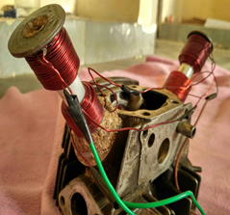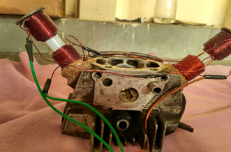

**Side View and Front view of Solenoid Operated CamlessEngine**

# EXPERIMENTATION(11 Bold)

A Regulated 5V DC power supply is feed to Arduino board and IC 7805 Voltage regulator. All microcontrollers operate at low voltages and require a small amount of current to operate while solenoids require higher voltages and current. Hence current cannot be supplied to the solenoid from the microcontroller .This is the primary need for IC L293D.A diode(**IN4007**) and a voltage regulator (**7805**) IC are connected in the path ,the diode is used as a one-way check valve. Since these diodes only allow electrical current to flow in one direction.IC 7805 is a 5V Voltage Regulator that restricts the voltage output to **5V** and draws 5V regulated power supply. A digital signal generated by Arduino based on the input program is feed to the L293D IC .L293D Is a voltage amplifier that amplifies the 5V into 12V.The L293D IC receives signals from the micro controller and transmits the relative signal to the solenoids .A L293D IC consists of 16 pins in total. 4 ground pins,4-input pins,4-output pins,2 voltage and enable pins. The digital signal output from 7 pin of arduino is feed to 10th pin of L293D(input),output from 7th pin is feed to 14th pin of L293D(output).The 4th,5th and the 13th,12th pins of L293D are grounded. L293D has an enable facility which helps you enable the IC output pins. If an enable pin is set to logic high, then state of the inputs match the state of the outputs. If you pull this low, then the outputs will be turned off regardless of the input statesDepending upon our power requirements we can use Transistors/MOSFETs as switches.

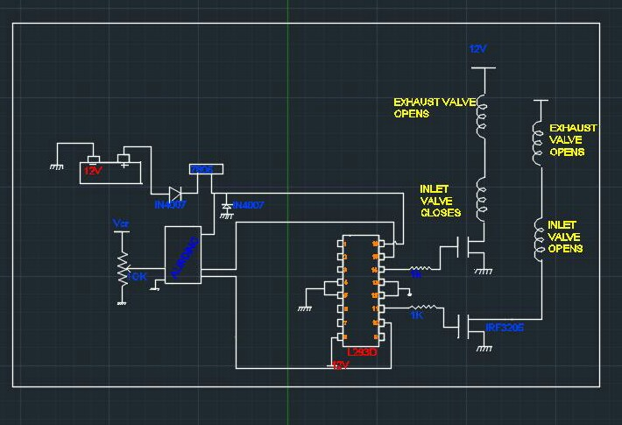

**LINE DIAGRAM FOR VALVE ACTUATION OF CAMLESS ENGINE**

The MOSFETs used are (IRF3205) which act as current amplifiers and amplify the current from 1 amp to 3 amps. Two solenoids are placed on the inlet and exhaust valves the piston of the solenoid is directly connected to the valve using a rubber tubing for motion transfer. Each solenoid consists of two set of copper windings with 12 mm dia,20 turns and 8 layered both the solenoid are oppositely connected and when actuated two sets of opposite windings get magnetized ,the piston inside solenoid moves up closing the valve the alternate valve is opened. The solenoids are rigidly placed over the cylinder head with the help of wood powder and glue which turns into concrete strong upon drying up. A solenoid is simply a specially designed electromagnet. A solenoid usually consists of a coil and a movable iron core called the *armature*. Here's how it works. When current flows through a wire, a magnetic field is set up around the wire. If we make a coil of many turns of wire, this magnetic field becomes many times stronger, flowing around the coil and through its center in a doughnut shape. When the coil of the solenoid is energized with current, the core moves to increase the flux linkage by closing the air gap between the cores. The movable core is usually spring-loaded to allow the core to retract when the current is switched off. The force generated is approximately proportional to the square of the current and inversely proportional to the square of the length of the air gap.

**SOURCE CODE FOR THE MICROPROCESSOR:**

intex_valve = 7;

intin_valve = 6;

intspd_ctrl = A0;

int del,del1;

void setup()

{

pinMode(ex_valve,OUTPUT);

pinMode(in_valve,OUTPUT);

pinMode(spd_ctrl,INPUT);

digitalWrite(ex_valve,HIGH);

digitalWrite(in_valve,HIGH);

}

void loop()

{

del=analogRead(spd_ctrl);

del1=map(del, 512, 0, 512);

if(del1<=20){del1=20;}

if(del1<=500){fire();}else

{

digitalWrite(ex_valve,HIGH);

digitalWrite(in_valve,HIGH);

}

}

void fire()

{

digitalWrite(ex_valve,HIGH);

digitalWrite(in_valve,HIGH);

delay(del1);

digitalWrite(ex_valve,LOW);

digitalWrite(in_valve,LOW);

}

# OBESERVATIONS FROM THE TESTS CONDUCTED SOLENOID FORCE

The actual force required in the application is need to move the engine valve along with spring that must be considered.

The force can be calculated by:

F = (N*I)2 μ0 A / (2 g2),

Where:

* μ0 = 4π�10-7
* F is the force in Newtons
* N is the number of turns
* I is the current in Amps
* A is the area in length units squared
* g is the length of the gap between the solenoid and a piece of metal.

For different N values we get different solenoid force for valve operating

I=5amp, g=0.5, A=πdl. (d =2mm,l=5cm,)

|  |  |  |  |
| --- | --- | --- | --- |
| SL.NO | NUMBER OF TURNS | SOLENOID FORCE | VALVE FREQUENCY PER SECOND |
| 1 | 100 | 0.512 N | 14 |
| 2 | 120 | 0.738 N | 18 |
| 3 | 140 | 1.001 N | 22 |
| 4 | 160 | 1.310 N | 25 |
| 5 | 180 | 1.661 N | 28 |
| 6 | 200 | 2.050 N | 33 |

**Valve Frequency**

At average speed i.e the valve opening or closing time is 40ms

For 1 sec 25 openings and closings is possible

For 1 min for one valve 25*60=1500

With a force of 1.31N the inlet valve opens for 1500 times and exhaust valve opens fo 1500 times.

|  |  |  |  |
| --- | --- | --- | --- |
| SL.NO | TIME TAKEN FOR ONE OPENING OR CLOSING IN MILLI SECONDS | NO OF OPENINGS OR CLOSINGS IN ONE SECOND | NO OF OPENINGS OR CLOSINGS IN MINUTE |
| 1 | 71.4 | 14 | 840 |
| 2 | 55.5 | 18 | 1080 |
| 3 | 45.45 | 22 | 1320 |
| 4 | 40 | 25 | 1500 |
| 5 | 35.7 | 28 | 1680 |
| 6 | 30.30 | 33 | 1980 |

# CONCLUSION

Looking back on this project, the overall outcome of results to be observed. This can be evaluated by looking at how well our objectives were met. Our first objective is to control the engine valve of an engine, select a linear actuator that meets specifications, and construct an electronic control system, deal with the design aspect of our project and were all almost achieved. More specifically, next objective, the electronic control system we constructed is able to read engine speeds from 0 to 3600 rpm and vary the valve timing depending on engine speed and operator inputs. However, our final objective, to obtain gains in horsepower, torque, and efficiency of 2% was not met because of not setting up in an engine but theoretically it should be done. We are confident though that this objective of installing in an engine can be met if more time for testing and facilities is given. There is a lot we could say about the need for variable valve timing. This design is very realistic for the future of the automotive industry as well as our education.

**SOME OF THE ADVANAGES FROM THE ABOVE RESULTS**

a)Eliminated Mechanical Linkages

b)It can make Engine clean , efficient and responsive

c)ECU can control the valve velocity acceleration and deceleration of valve

d)Reduction in size and weight

e)Fuel economy Increases

f)Power and Torque increase

**REFERENCES**

## Anderson, M; Tsao, T-C; and Levin, M., 1998, “Adaptive Lift Control for a Camless Electrohydraulic Valvetrain,” SAE Paper No. 98102

1. Ashhab, M-S; and Stefanopoulou, A., 2000, “Control of a Camless Intake Process – Part II,” ASME Journal of Dynamic Systems, Measurement, and Control – March 2000
2. Gould, L; Richeson, W; and Erickson, F., 1991, “Performance Evaluation of a Camless Engine Using Valve Actuation with Programmable Timing,” SAE Paper No. 910450.
3. Schechter, M.; and Levin, M., 1998, “Camless Engine,” SAE Paper No. 960581
4. INTERNATIONAL JOURNAL OF ROBUST AND NONLINEAR CONTROL, *Int*. *J*. *Robust Nonlinear Control* 2001; 11:1023}1042 (DOI: 10.1002/rnc.643) **(10)**